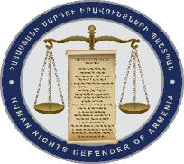
OFFICE OF THE HUMAN RIGHTS DEFENDER
OF THE REPUBLIC OF ARMENIA
PUBLIC RELATIONS UNIT

The Defender welcomes the release of
Nikol Pashinyan, Sasun Mikayelyan and Ararat Mirzoyan

Today, early in the morning the Human Rights Defender Arman Tatoyan visited Police detention facility in Yerevan to meet member of National Assembly Nikol Pashinyan. A private interview was held. Issues related to insurance of Nikol Pashinyan’s rights, including with regard to his arrest, exercise of right to lawyer and other issues were discussed.
As a reminder, yesterday, the Defender Arman Tatoyan also visited members of RA National Assembly Ararat Mirzoyan, Sasun Mikayelyan, as well as Davit Sanasaryan, Armen Grigoryan and several other arrested persons. Private interviews were held with them, their keeping conditions and respective documents were examined. No complaints related to their keeping conditions and treatment by officers of the detention facility have been raised.
The Human Rights Defender welcomes the release of members of National Assembly Nikol Pashinyan, Sasun Mikayelyan and Ararat Mirzoyan.

