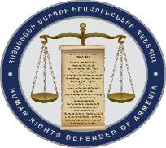
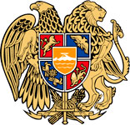
OFFICE OF THE HUMAN RIGHTS DEFENDER
OF THE REPUBLIC OF ARMENIA
PUBLIC RELATIONS UNIT

I specifically demand from public officers and persons engaged in public activities to promote safeguarding atmosphere of solidarity and mutual respect by their own conduct

The widespread insult, infringement of dignity and hate speech within the Internet namely in social media is rigorously concerning. Targeted observation of the matter indicates that a society continues to be intolerant to dissent on various issues and suppression of the dissent is accompanied by aggressive reactions.
Frequently, the content of the speech or point made is not taken into consideration, or it is done only taking into consideration the personality of the opinion maker. The matte of concern continues to exist in our society for a long period of time jeopardizing safeguard of the solidarity and tolerance in the society and human rights system, in general.
Our country currently undergoes fundamental challenges of systemic nature and faces human rights challenges. We must target all the issues upholding solidarity and mutual respect in the society in order to successfully overcome all the challenges and tackle existing problems entirely. Once again, I call on to cease all the attempts to divide the society into “predecessors” and “successor” or to be guided by such separative principles.
I ask everyone to take into consideration all the raised observations.
I especially demand from public officers and persons engaged in public activities to strictly adhere the boundaries of their legal status enshrined in the Constitution, laws and other legal acts and to maintain solidarity and uphold mutual respect by their own conduct.
Arman Tatoyan
The Human Rights Defender of the RA

